TERMS AND CONDITIONS FOR THE WARZONE SOLO LEADERBOARD
- ACCEPTANCE: By entering this competition, you agree you have read and accept these terms and conditions. We reserve the right to verify any entries and winners and may refuse to award prizes where we have reasonable grounds to believe that there has been a breach of these terms and conditions. You can access these terms and conditions at any time during the competition at www.game.co.uk/terms. We suggest that you keep a copy of these terms for your own records.
- ELIGIBILITY: You may enter this competition if you are resident in the UK and 18 years old or older. You must have an active GAME Reward account in which you have registered your age, valid email address, and location so we can contact you if you are a winner. You are not eligible to enter this competition if you, or a member of your immediate family (which means parents, children, siblings, spouse and life partners), are an employee, contractor or sub-contractor of GAME, Game Esports and Events Limited or Ads Reality Limited, or any of their advertising or promotion agencies. The details you provide upon registration for the competition must match the details associated with your Reward Account. You promise that all the personal information you provide to GAME in connection with this competition shall be complete and accurate.
- HOW TO ENTER: You can sign up by visiting a Belong arena from Sunday 26th July – 6pm Sunday 2nd August 2020.
- The weekly leaderboards will be held on a 1v1 basis on PC from Sunday 26th July – 6pm Sunday 2nd August 2020. Leaderboards will reset every Sunday throughout the duration of the tournament. The tournament will be held in accordance with our tournament rules, copies of which are available on request
- Points will be awarded to the players, based on where they finish in each match, in accordance with the following table. Each player will also receive a bonus of 50 points per kill recorded by them in each game. We will record the best 3 attempts for the week.
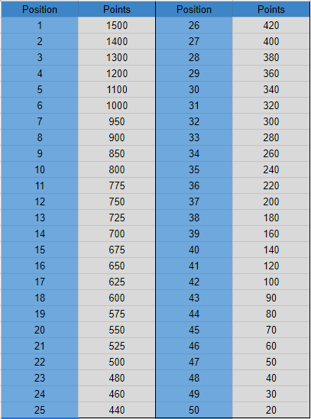
- You promise that your entry is original and owned by you, and you have not borrowed or copied it (in whole or in part) from anyone else or asked anyone to participate on your behalf.
- INVALID ENTRIES: Any entry made or attempted to be made to the competition in a manner which in our reasonable opinion is contrary to these terms and conditions or by its nature unfair to other participants will be invalid and may result in your disqualification from the competition. Examples of entries or behaviour which are not allowed include fraudulent entries, bulk entries, automated entries, entries made on behalf of another person, cheating (including a person participating in the competition on your behalf), hacking, deception (including tampering with the challenge settings which will result in immediate disqualification from the entire competition), use of robots or other automated programmes. We will not accept illegible or incomplete entries.
- SELECTION OF WINNERS: The winners for the Warzone solo leaderboard will be determined in accordance with the tournament rules.
- PRIZE: The prizes are that:
For the Fortnite solo leaderboard:
- 1st Place – 500gb PS4 console
- We may substitute prizes of equal or greater value. Non-cash prizes have no cash value and cannot be exchanged for cash. Prizes are not transferable. Prizes may be considered a taxable benefit and the winner will be directly responsible for any taxes payable on their prize. Only one prize will be awarded to each winner.
- OWNERSHIP OF YOUR ENTRY: You own your entry, including any copyright in your entry. By entering the competition, you agree that GAME (including our group and affiliate companies) may edit, publish and use your entry in any and all media (including print and online) for promotion and news purposes, both during and after the competition, without any payment to you.
- NOTIFICATION OF WINNERS: We will notify the winners by email (to the email address associated with your GAME Reward account) at 6pm on 4th August 2020. We may ask winners to submit valid identification before we send you the prize.
- FAILURE TO CLAIM PRIZE: We will make all reasonable attempts to notify the winners. If we are not able to contact potential winners by 6pm on 6th August 2020 then we may withdraw your prize entitlement, select another winner from among the valid entries.
- DELIVERY OF PRIZE: Winners will be invited to collect their prize from the BELONG Arena in which they participated from 6pm on 10th August 2020 onwards.
- LIST OF WINNERS: You may request the last name and county of the prize winners by sending a stamped addressed envelope to BELONG Fortnite solo leaderboard, Game Retail Limited, Unity House, Telford Road, Basingstoke, RG21 6YJ. By entering this competition, you give us permission to make available your last name and county if you win.
- FINAL DECISION: Our decision is final. No correspondence will be entered into regarding the selection of the winner of this competition.
- CONSENT TO USE NAME AND IMAGE: We may require the winners to participate in publicity or advertising. By entering this competition, you agree that we may use your name and/or image for these purposes and that you will not be paid.
- YOUR PERSONAL INFORMATION: When you give us the information, we ask you for as part of the competition, we’ll use it as needed to conduct the competition as we’ve described in these terms. We may also use it for other reasons, but we’ll ask for your permission before we do. We will process, use and store your data in accordance with our Privacy Policy which can be found at www.game.co.uk/privacypolicy
- OUR LIABILITY TO YOU: We accept liability for death or personal injury caused by our negligence or that of our employees and agents. We do not seek to exclude liability for fraud by us or our employees or agents. For any other loss or damage, we will only be liable for losses which are a reasonably foreseeable consequence of our negligence or breach of these terms and conditions, up to a maximum of £100. Losses are foreseeable where they could be contemplated by you and us at the time of you entering this competition.
- WHAT WE ARE NOT LIABLE FOR: We are not responsible for:
  - losses not caused by our breach or negligence
  - indirect losses – these are losses which are a side effect of the main loss or damage and which are not reasonably foreseeable by you and us at the time of you entering this competition
  - entries lost, delayed, damaged or corrupted where such loss, delay, damage or corruption is caused by events outside of our reasonable control
  - technical failures or errors affecting communication lines, website availability or systems errors where these are not within our reasonable control, or
  - any failure to provide the competition, the prize(s) or to meet any of our obligations under these terms and conditions where that failure arise because of events outside of our reasonable control.

- LIABILITY OF THIRD PARTIES: You acknowledge that some prizes are provided by a third party not related to GAME. We are not responsible for the performance of any third party involved in this competition or the provision of the prizes and will not be liable for any act or omission of a third party, although we will endeavour to minimise the effect to you of any third party's failure. Third party terms may apply to prizes details of which can be provided upon request.
- DISPUTES: If you wish to take court proceedings against GAME you must do so within the United Kingdom. The law of the part of the United Kingdom of which you are a resident shall apply, for example, if you live in England the laws of England shall apply and if you live in Scotland the laws of Scotland shall apply.
- DETAILS OF PROMOTER: This competition is run by Game Retail Limited (“GAME”) a company registered in England and Wales. Our registered address is Unity House, Telford Road, Basingstoke, RG21 6YJ.

